User manual for Assisted Living App

Table of Contents

1. Login
   1. Connecting to internet
2. Admin Processes
   1. Create users
   2. Create case files
   3. Assign users
   4. Close case files
3. Field user Processes
   1. Loading case file
      1. Loading from the web
      2. Loading Locally
   2. Adding forms
   3. Editing forms
      1. Expandable textbox
      2. Date Picker
      3. Layout Repeater
   4. Saving forms
      1. Saving to web
      2. Saving to local
4. Printing
5. **Login**

When first launching application a window like the one below will appear.

Simply enter username and password assigned to you then click Login.

\\netstorage.eastern.ewu.edu\nhuff2\sp screen\toolbar.PNG

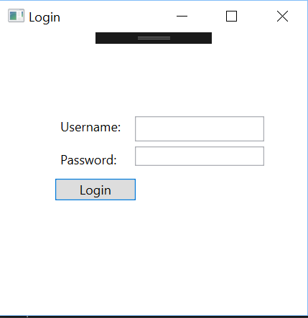If you need to change who is logged in click Login on the top left of the window.

* 1. **Connecting to the internet**

Logging in with a working internet connection connects the application to the internet.

1. **Admin Processes**

These processes are only available for accounts with admin privileges and when the application is connected to the internet

* 1. **Create Users**

\\netstorage.eastern.ewu.edu\nhuff2\sp screen\toolbar.PNGClick on “Admin” on the top left of the window.

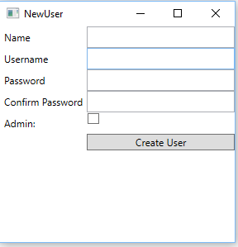In the drop down menu click “Create User”

Fill in the different fields:

Name: Full name of user

Username: Username to be assigned

Password: Password to be Assigned

Admin: Check the box if the account will have admin privileges

After all the fields are filled out click “Create User” and the user account will be created

* 1. **Creating Case File**

**\\netstorage.eastern.ewu.edu\nhuff2\sp screen\toolbar.PNG**Click on “Admin” on the top left of the window.

In the drop down menu click “New Case File”

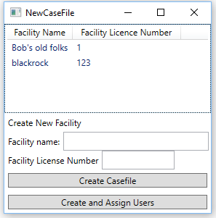

Either click a facility from the list at the top of the window or fill in Facility name and Number.

Click “Create Casefile” to create the Casefile but not assign anyone to it

or

Click “Create and Assign Users” to assign users to that Casefile

See section 2.3. Assign Users for instructions on how to use Assign user window

* 1. **Assign Users**

Before doing this be sure to either be in creating a casefile or have a casefile already loaded in.

**\\netstorage.eastern.ewu.edu\nhuff2\sp screen\toolbar.PNG**Click on “Admin” on the top left of the window.

In the drop down menu click “Assign User”

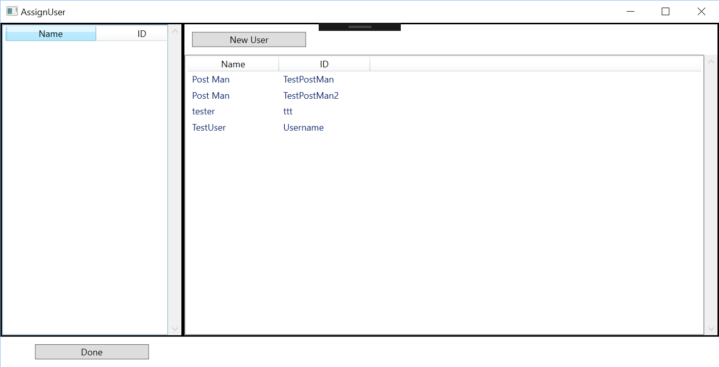

In the list to the right of the window double click the user you want to assign to the casefile

If you need to create a new account, click the “New User” button at the top of the window (See Section 2.1 Create User for instructions on how to use this screen)

After creating the new user just double click the name to assign the user.

To remove a selected user double, click their name from the list on the left.

After all users have been selected click “done” on the bottom of the window

* 1. **Closing a casefile**

\\netstorage.eastern.ewu.edu\nhuff2\sp screen\toolbar.PNGClick on “Admin” on the top left of the window

Click “Close Case File”

Doing this will mark the casefile as closed and will not allow anyone to edit it. Clicking “close casefile” will automatically save the current case file to the computer and save it to the web

1. **Field user Processes**
   1. **Loading Casefile**
      1. **Loading from the web**

\\netstorage.eastern.ewu.edu\nhuff2\sp screen\toolbar.PNGClick “File” on the top left of the window

Click “Load”

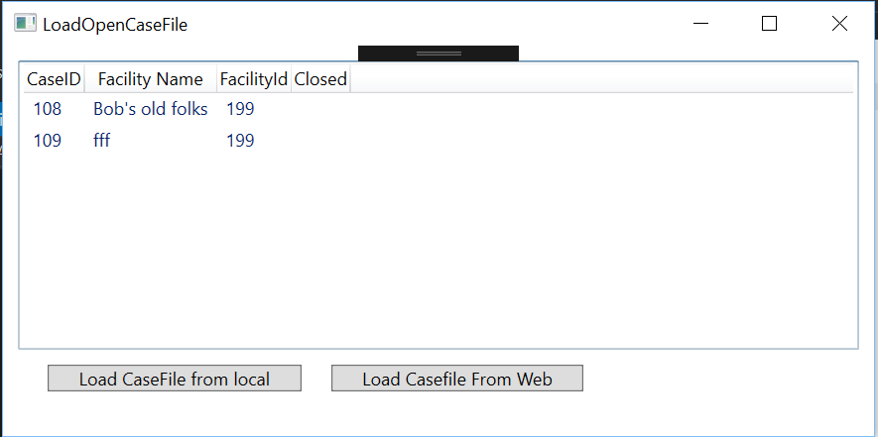

Wait for the list on the top half of the window to populate from the web

If a label appears at the bottom of the window saying “cannot connect” you cannot load from the web.

Either double click the casefile you want from the list shown on the window or click once then click “Load Casefile from Web”

* + 1. **Loading locally**

\\netstorage.eastern.ewu.edu\nhuff2\sp screen\toolbar.PNGClick “File” on the top left of the window

Click “Load”



Click “Load Casefile from local”

Use the file explorer to select the casefile you want to load

Casefiles tends to be saved as their “Case<case id number>” unless saved under a different name

* + 1. **Loading from web**

\\netstorage.eastern.ewu.edu\nhuff2\sp screen\toolbar.PNGClick “File” on the top left of the window

Click “Load”



Double click a casefile you want to load or click once then click “Load Casefile From Web”

* 1. **Adding forms**

\\netstorage.eastern.ewu.edu\nhuff2\sp screen\toolbar.PNGWhen a case file is loaded, and you are an inspector working on a report for that casefile click “AddForm” on the top left of the window

Double click the form you want to add of click once then click “Add Form”

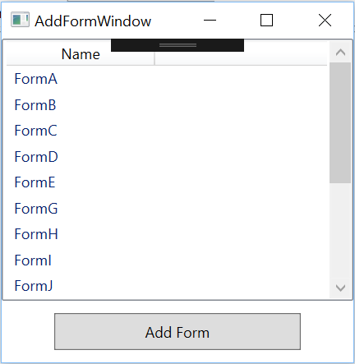

* 1. **Editing forms**

You can only edit reports and forms you are assigned to and are still open

Most fields you just click inside the textbox and enter the data

To toggle checkboxes just click on them to check or uncheck them

* + 1. **Expandable Textbox**

Some textboxes, like Notes at the bottom of most forms, you can press the enter key and will expand. You can enter as much text as you want here.

* + 1. **Date Picker**

To use a date picker, click on the calendar image to the right of the field.

Click the date you want to enter

* + 1. **Layout Repeater**

Some forms, like the resident list have a field called Layout Repeater

Clicking the button that says “Add <some item>” will create another row of that item

An Example is in Form C with add resident. You can click “add resident” as many times as you need to create enough row for all residents.

* 1. **Saving the casefile**
     1. **Saving to the web**

\\netstorage.eastern.ewu.edu\nhuff2\sp screen\toolbar.PNGClick “File” on the top left corner of the window

Click “Merge”

* + 1. **Saving locally**

\\netstorage.eastern.ewu.edu\nhuff2\sp screen\toolbar.PNGClick “File” on the top left corner of the window

Click “Save”

You can change the name of the save file or it will save as the “Case<case id number>”

Click save

1. **Printing**

\\netstorage.eastern.ewu.edu\nhuff2\sp screen\toolbar.PNGClick “File” on the top left corner of the window

Click “Print” in the drop-down menu

Click the printer you want to print to

Select number of copies you want

Click “Print”